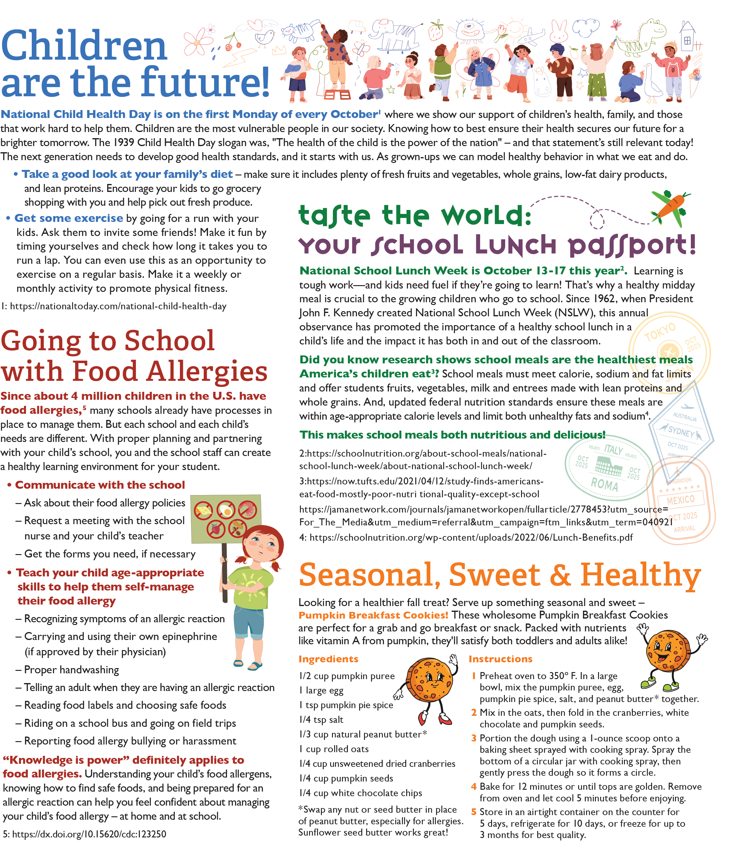

<https://schoolnutrition.org/wp-content/uploads/2022/06/Lunch-Benefits.pdf>

<https://jamanetwork.com/journals/jamanetworkopen/fullarticle/2778453?utm_source=For_The_Media&utm_medium=referral&utm_campaign=ftm_links&utm_term=040921>

<https://now.tufts.edu/2021/04/12/study-finds-americans-eat-food-mostly-poor-nutritional-quality-except-school>

<https://schoolnutrition.org/about-school-meals/national-school-lunch-week/about-national-school-lunch-week/>

<https://dx.doi.org/10.15620/cdc:123250>

<https://nationaltoday.com/national-child-health-day>

<https://rethinkschoolmeals.com/>

<https://www.conagrafoodservice.com/>